People: You have been (and are being) lied to!!

A few scientists, politicians and activists have been lying to the public for over 30 years. They say that global change is due to CO₂ in the atmosphere. Al Gore became very rich with this hypothesis. Some “scientists” have also made a living by espousing this hypothesis with fancy mathematical models and scientific jargon. And, of course, activists that want publicity and cleaner air by ceasing the use of fossil fuels, and converting to wind, solar, tidal, and battery alternatives.

The real reason:

The reason behind global change, if it is truly caused by humans, is the number of people on the planet and the energy they consume. Figure 1 and Table 1 show this very clearly. The graph shows that in 1960 the world energy consumption was about 150 exajoules per year. An exajoule is 10¹⁸ joules. ( a joule is a watt second, or 1 volt x 1 amp into a 1 ohm resistor for one second). An exajoule is a very large number. In 2010, world consumption was about 550 exajoules, or 3.6 times greater. Over that same time period (1960-2010), the world population increased from 3.04 billion to 7.8 billion, or by a factor of 2.3 (Table 1).

It is apparent that energy consumption per person is also increasing (by about 50%). In contrast, atmospheric CO₂ in 1960 was about 310 parts per million and in 2020 was about 410 ppm, an increase of 1.3 times as shown in Figure 2. (Source: NOAA Earth System Research Laboratory, Mauna Loa Laboratory.)

Population growth, increases in technology and, as the world improves its “quality of life” lead to the real reason for global warming. Every radio, cell phone, stereo, TV set, light bulb, slot machine, motor, and yes, even muscle movement produces heat. This heat is low level infra-red in most cases and gets absorbed by buildings, air, trees, water, animals and vegetation, etc. If it is extensive enough we will see a warming trend. If you watch the nightly news, you are also aware that large metropolitan areas produce “heat islands” in the evenings. This is due to all the buildings absorbing heat during the day, and slowly releasing it when the sun goes down. Thus, as urban areas gain population and grow, the heat islands also grow. Vegetation also stores this heat energy.
Regardless of the source of energy and its use, most of it ends up as heat. So, can we tell people to turn off their cell phones, TV’s, computers, air conditioning units, etc. We could, but nobody would listen, much less obey.

Why the lie?

Atmospheric CO₂ is an attackable objective. To reduce the carbon dioxide in the atmosphere, one simply has to attack the sources of it. Decaying vegetation in the oceans and forests generate about 90% or more of the atmospheric carbon dioxide. We cannot stop this process without dire consequences. Probably the next most common source is the use of fossil fuels. Breathing also produces CO_{2 ,} but you cannot tell people to quit breathing.

So-o-o. a few people scream loudly that we are destroying our planet. And, we are destroying our planet because we use fossil fuels. It is my contention that the increase in population and subsequent increase in energy production/consumption is the real cause of climate change.

The facts

By far, most of the energy produced ends up as low level heat, which is absorbed on the earth’s surface, be it water or land. And, warming of this surface increases the rate of CO₂ release to the atmosphere. (Warmer ground temperatures speed up the decay of vegetation and warming of water decreases the solubility of CO₂.) When you take all of this into consideration, fossil fuels contribute very marginally to the annual release of carbon dioxide. Given this scenario, converting to an all-electric society will do little to impact atmospheric CO₂.

Figure 1. World Energy Consumption

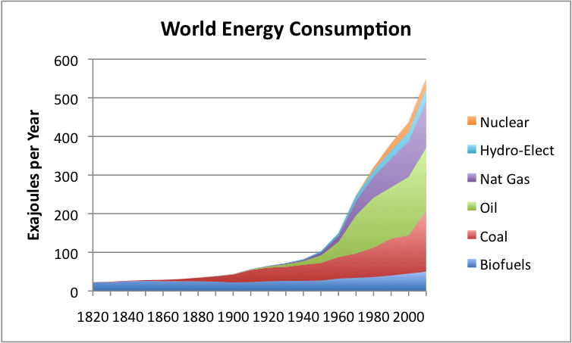

Table 1. World Population Since 1950

Year | World Population
1950 | 2,556,000,053
1960 | 3,039,451,023
1970 | 3,706,618,163
1980 | 4,453,831,714
1990 | 5,278,639,789
2000 | 6,082,966,429
2010 | 6,956,823,603
2020 | 7,794,798,739

An alternative theory is that CO₂ shows normal fluctuations in the atmosphere. During the last ice age, some 20,000 years ago, atmospheric CO₂ levels are estimated to be about 180 ppm. Prior to the pre-industrial age, it had increased to 280 ppm, largely attributed to outgassing from the warming oceans. I would note here that, prior to 1960, CO₂ levels in the atmosphere are based on air bubbles trapped in glacial ice for historical data. How accurate such a methodology is might be questioned. I, personally, might prefer air trapped in amber over such long periods of time.

Figure 2.
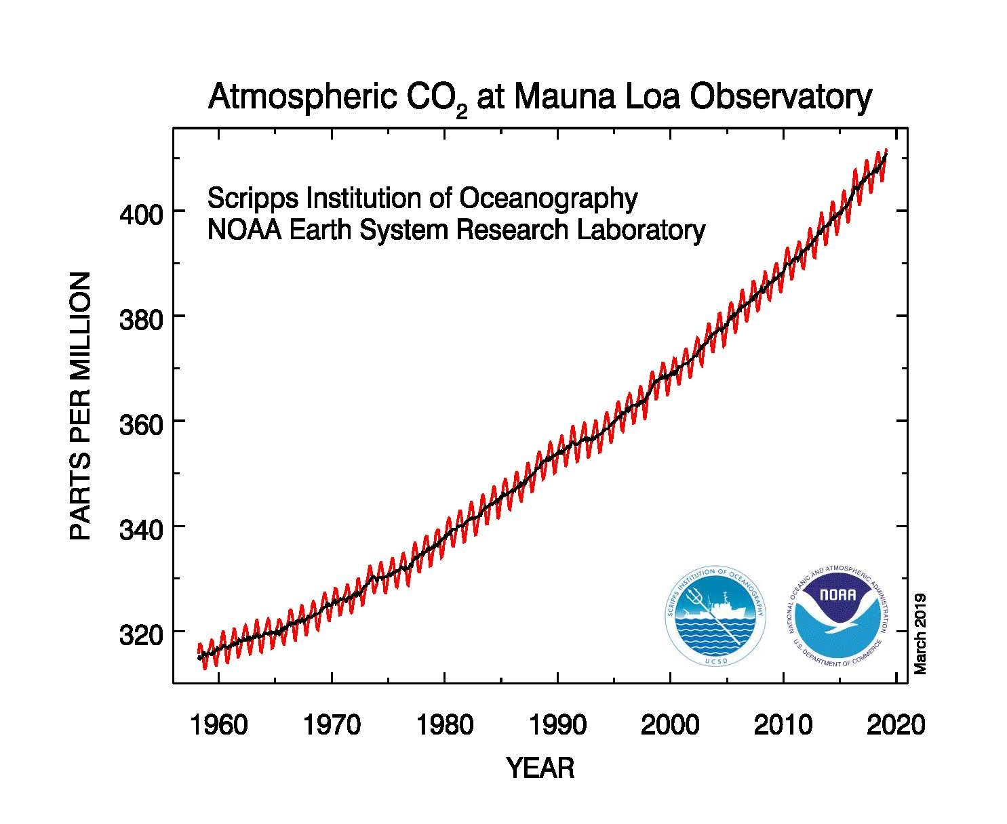

- Some people are misguided and blame climate changes on atmospheric CO₂ because they a. want the spotlight or b. make a living by supporting it.
- Global warming is not due to fossil fuel burning.
- Global warming is due to world energy production/consumption.

So, people, if you really want to control climate change, turn off your all your heat warming devices. Wear long johns and insulated clothing in the winter because you cannot heat your home, and swelter in the hot weather, because there will be no air-conditioning in your home or automobile. Also, no TV, cell phones, computers, stereos, ipads or pods. What a world!!

Author: M. Hammond, retired scientist.

